SIMATS ENGINEERING
ASSESSMENT TOOL 1

COURSE CODE: CSA04
COURSE NAME: Operating Systems

COURSE OUTCOME COVERED

CO1: Apply the concepts of Operating System types, structures, and system calls to demonstrate their functions in various computing environments.

QUESTIONS: 5 Total Marks:100

Annexure A

SHORT ANSWER TEST

Code of Conduct:

I YUVANSHANKAR U(192511265) (Name / Reg No) certify that this submission is my original work and that I have adhered to the guidelines specified for this assessment.
I understand that any violation of academic integrity rules will result in disciplinary action.

Signature of the student:



Annexure A

Short Answer Test

Question 1 (5 Marks)
Suppose a modern Operating System supports multiple users and processes with shared resources like CPU, memory, and I/O devices.
(a) Classify different types of Operating Systems suitable for this scenario and justify your choice.
(b) Draw the structure of an Operating System showing how resources are managed.
(c) Write a sequence of system calls required to create and execute a new process in such an environment. (BL2)

Question 2 (5 Marks)
Consider an Operating System managing multiple files and devices for concurrent users.
(a) Categorize system calls used for file and device management.
(b) Illustrate how the OS handles file operations using a layered structure diagram.
(c) Write a pseudo-code or C-based system call sequence to open, read, and close a file. (BL3)

Question 3 (5 Marks)
Assume a real-time Operating System used in an embedded system controlling industrial machinery.
(a) Identify the type of OS and explain why it is suitable for real-time applications.
(b) Draw a diagram representing the interaction between hardware, kernel, and user processes.
(c) List and explain system calls required for process synchronization in this system. (BL2)

Question 4 (5 Marks)
A distributed computing system consists of multiple interconnected computers sharing resources over a network.
(a) Classify the type of Operating System used and compare it with centralized OS.
(b) Draw the architecture of a distributed OS showing communication between nodes.
(c) Write the sequence of system calls involved in inter-process communication (IPC). (BL3)

Question 5 (5 Marks)
Consider a scenario where an Operating System must manage process scheduling, memory allocation, and device communication efficiently.
(a) Explain the major functions of an OS in handling these tasks.
(b) Draw a block diagram representing OS components and their interactions.
(c) Write system call examples for memory allocation and device management. (BL3)

RUBRICS FOR CALCULATION

Criteria | Weightage (Marks) | Level 4 – Exemplary (Full Marks) | Level 3 – Proficient | Level 2 – Developing | Level 1 – Beginning
Conceptual Understanding | 35 Marks | Demonstrates clear, complete, and in-depth understanding of OS concepts (types, structure, system calls) | Good understanding with minor gaps | Basic understanding with some misconceptions | Poor or incorrect understanding
Accuracy of Answers | 25 Marks | All answers are correct, precise, and relevant | Mostly correct with minor errors | Partially correct with noticeable errors | Mostly incorrect or irrelevant
Application of Knowledge | 15 Marks | Effectively applies concepts to scenarios/questions | Applies with minor mistakes | Limited or partial application | No meaningful application
Completeness of Response | 15 Marks | All parts of each question are fully answered | Most parts covered with small omissions | Some parts missing | Incomplete answers
Clarity & Presentation | 10 Marks | Clear, well-structured, and neatly presented answers | Understandable with minor issues | Somewhat unclear or poorly structured | Difficult to understand

Question 1:
Operating System (OS): system software that acts as an interface between the user and the computer hardware and manages shared resources such as the CPU, memory and I/O devices.

(a) Types of Operating Systems suitable for the scenario
OS Type | Brief description | Role in this scenario
Multiprogramming | Keeps several programs in memory; when one waits for I/O, the CPU switches to another. | Maximises CPU utilisation.
Time-sharing (Multitasking) | CPU time is divided into small time slices and switched rapidly between processes. | Gives every user a quick, interactive response.
Multiuser | Many users work at the same time with separate accounts, protection and resource limits. | Needed for multiple users on shared resources.
Multiprocessor (Parallel) | Two or more CPUs share memory and I/O under one OS. | Higher throughput and reliability.

Justification: the scenario has many users and processes sharing the CPU, memory and I/O devices, so the best choice is a multiuser, time-sharing, multiprogramming OS (for example Linux, UNIX, Windows Server) running on multiprocessor hardware. A batch OS lacks interactivity, a single-user OS cannot protect users from each other, and a real-time OS is meant for deadline-driven tasks, not general sharing.

(b) Structure of an Operating System and resource management
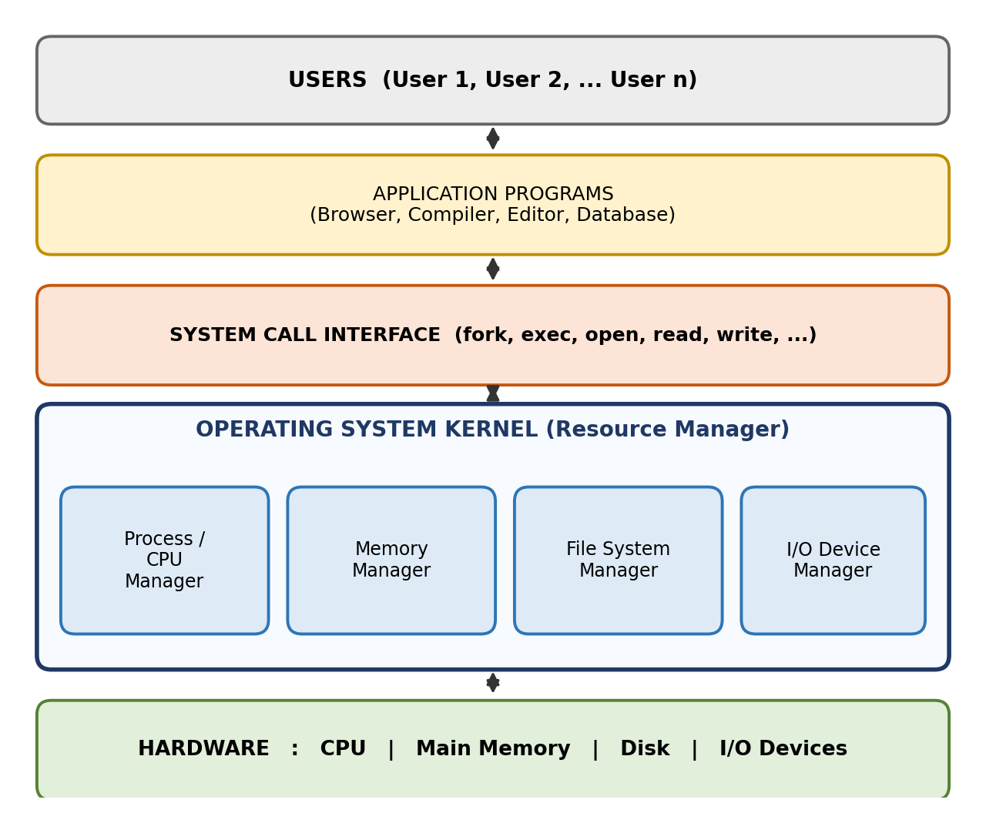
Fig. 1: Layered structure of an OS showing resource management
- Process/CPU manager: creates, schedules and terminates processes.
- Memory manager: allocates and frees memory, keeps each process in its own address space.
- File system manager: organises files and directories on disk and controls access.
- I/O device manager: controls devices through drivers and queues I/O requests.

(c) System calls to create and execute a new process
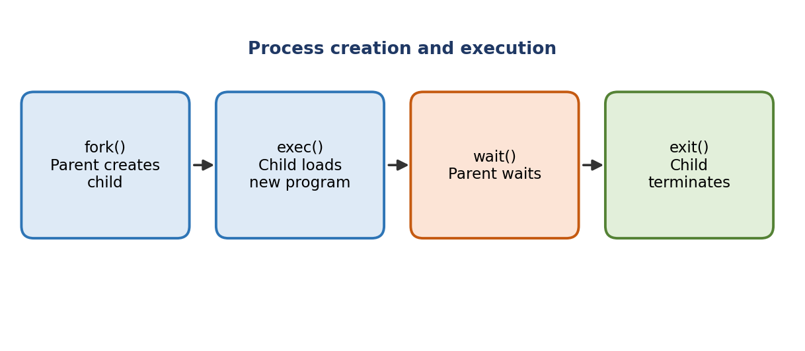
Fig. 2: Sequence of system calls for process creation
Step | System call | Function
1 | fork() | Creates a child process (copy of the parent). Returns 0 to the child and the child's PID to the parent.
2 | exec() family | Child replaces its memory image with a new program.
3 | wait() | Parent blocks until the child finishes.
4 | exit() | Child terminates and returns its status to the parent.

#include <stdio.h>
#include <unistd.h>
#include <sys/wait.h>
int main() {
pid_t pid = fork(); // 1. create new process
if (pid < 0) {
perror("fork failed");
} else if (pid == 0) { // child
execlp("echo", "echo", "Child: new program", NULL); // 2. exec
} else { // parent
wait(NULL); // 3. wait for child
printf("Parent: child complete\n");
}
return 0;
}

Output:
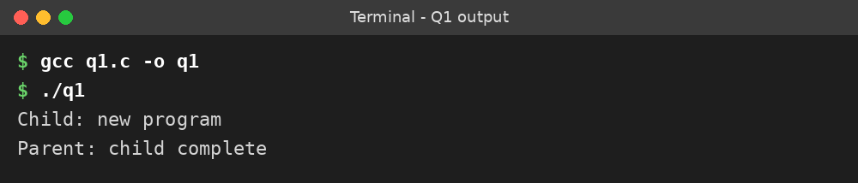
Summary: A multiuser, time-sharing, multiprogramming OS shares the CPU, memory and I/O among many users. The kernel sits between applications and hardware, and a new process is created with fork() and exec(), then reaped with wait().

Question 2:
File management deals with creating, storing, accessing and protecting files. Device management controls I/O devices through drivers. Both are reached by user programs through system calls.

(a) Categories of system calls for file and device management
Category | System calls | Purpose
File management | create(), open(), read(), write(), lseek() (reposition), close(), unlink() (delete), stat() / chmod() (get/set attributes) | Create, delete, open, read, write, move within a file and manage file attributes.
Device management | request device (open()), ioctl() (get/set attributes), read(), write(), reposition, release device (close()) | Request a device for exclusive use, do I/O, configure it and release it.

UNIX-like systems treat devices as special files (for example /dev/sda), so the same open/read/write/close calls work for both files and devices.

(b) File operations using a layered structure
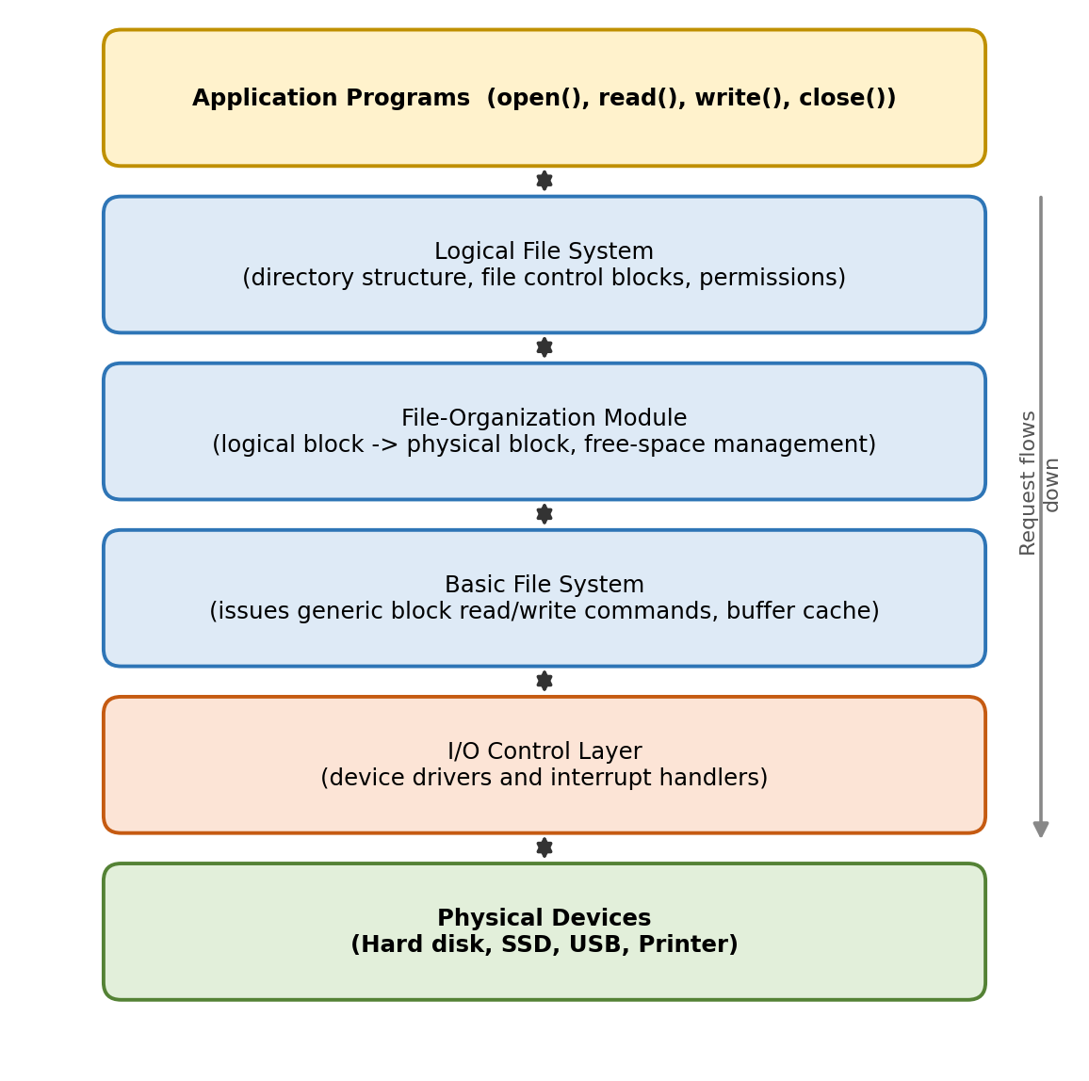
Fig. 3: Layered file system
How a request is handled when a program calls open() / read():
- Logical file system: finds the directory entry, checks permissions and loads the file control block (FCB).
- File-organization module: converts the logical block number into a physical block address and manages free space.
- Basic file system: sends a generic read/write command for that block, using the buffer cache.
- I/O control layer: the device driver converts the command into hardware instructions; the device returns data by interrupt.
- The data then travels back up the layers to the application.

(c) System call sequence: open, read, close
Sequence: open() → read() → (write() to display) → close()
#include <fcntl.h>
#include <unistd.h>
#include <stdio.h>
int main() {
char buf[100];
int fd = open("data.txt", O_RDONLY); // open file
if (fd < 0) { perror("open"); return 1; }
int n = read(fd, buf, sizeof(buf)); // read data
if (n > 0) write(1, buf, n); // show on screen
close(fd); // close file
return 0;
}

Output:
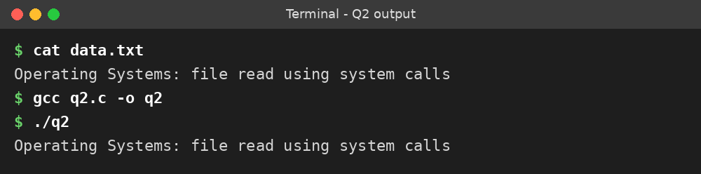
Summary: System calls for files (open, read, write, close) and devices (ioctl, read, write) pass through the layers: logical file system, file-organization module, basic file system and I/O control, down to the physical device.

Question 3:
Real-Time Operating System (RTOS): an OS that guarantees a response within a fixed deadline. Correctness depends on both the result and the time at which it is produced.

(a) Type of OS and why it suits real-time applications
The scenario (industrial machinery control) needs a Hard Real-Time Operating System (examples: VxWorks, QNX, FreeRTOS). Missing a deadline could damage machinery or cause injury.
- Deterministic timing: tasks always finish within a guaranteed time.
- Priority-based pre-emptive scheduling: a high-priority task (for example emergency stop) immediately pre-empts a lower one.
- Low interrupt latency: external events from sensors are handled very quickly.
- Small, fast kernel: minimal overhead, ideal for embedded hardware.
- Reliability: predictable behaviour with no unpredictable delays.

(b) Interaction between hardware, kernel and user processes
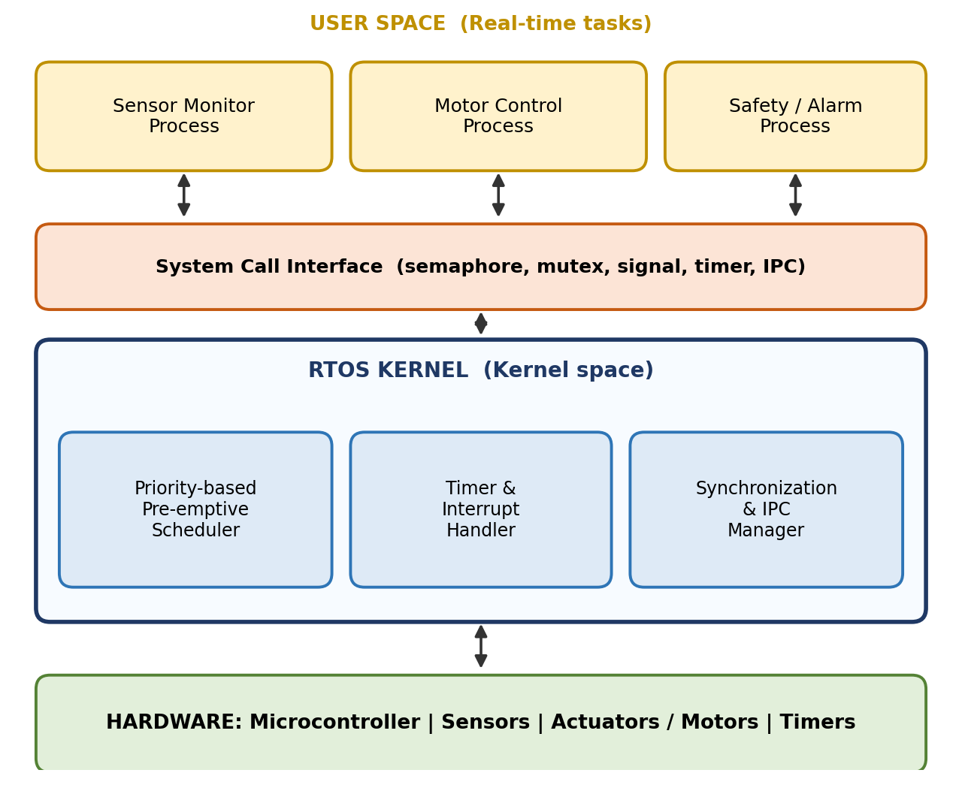
Fig. 4: Hardware, kernel and user process interaction in an RTOS
User processes request kernel services through system calls. The kernel's scheduler, timer/interrupt handler and synchronization manager control the hardware (sensors and actuators). Hardware events reach the kernel as interrupts, and the kernel passes results to the right process.

(c) System calls for process synchronization
System call | Explanation and use in this system
sem_init(), sem_wait(), sem_post() | Semaphore operations. sem_wait (P) decrements and blocks if the value is zero, sem_post (V) increments and wakes a waiting task. Used to control access to a shared sensor buffer.
pthread_mutex_lock(), pthread_mutex_unlock() | Mutual exclusion: only one task at a time may use a shared resource such as a motor controller. Priority inheritance avoids priority inversion.
pthread_cond_wait(), pthread_cond_signal() | A task sleeps until a condition holds (for example "sensor data ready") and is woken by another task.
mq_send(), mq_receive() | Message queues pass sensor readings to the controller task safely and in order.
kill() / signal() | Delivers asynchronous events such as an emergency-stop alert.
wait() / waitpid() | A parent task waits for a child task to complete.

Example: protecting shared data with a binary semaphore
#include <stdio.h>
#include <pthread.h>
#include <semaphore.h>
sem_t mutex;
int shared = 0; // shared machine counter
void *task(void *arg) {
for (int i = 0; i < 1000; i++) {
sem_wait(&mutex); // P(): enter critical section
shared++; // update shared data
sem_post(&mutex); // V(): leave critical section
}
return NULL;
}
int main() {
pthread_t t1, t2;
sem_init(&mutex, 0, 1); // binary semaphore
pthread_create(&t1, NULL, task, NULL); // sensor task
pthread_create(&t2, NULL, task, NULL); // control task
pthread_join(t1, NULL);
pthread_join(t2, NULL);
printf("Final shared value = %d (expected 2000)\n", shared);
sem_destroy(&mutex);
return 0;
}

Output:
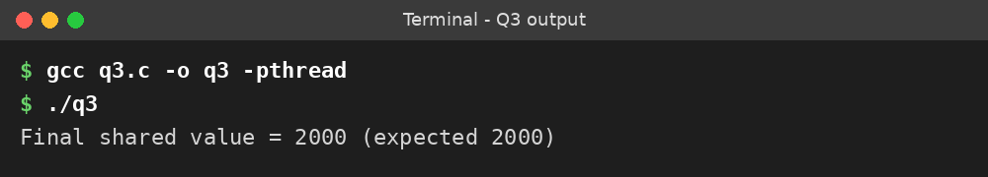
Summary: An industrial controller needs a hard RTOS with deterministic, priority-based scheduling. Semaphores, mutexes, condition variables and message queues keep tasks synchronized so shared data is never corrupted.

Question 4:
Distributed Operating System: an OS that manages a group of independent, networked computers and makes them appear to the user as a single system by sharing resources transparently.

(a) Type of OS and comparison with a centralized OS
The scenario describes a Distributed Operating System (examples: Amoeba, LOCUS, Sprite).
Feature | Centralized OS | Distributed OS
Computers managed | A single computer | Many interconnected computers (nodes)
Communication | Shared memory, local IPC | Message passing over the network (RPC)
Resource sharing | Within one machine | Across all nodes in the network
Reliability | Single point of failure | Fault tolerant: other nodes continue if one fails
Scalability | Limited by one machine | Easy: add more nodes
Performance | Limited to one CPU/system | Parallel processing and load sharing
Complexity / cost | Simple, low cost | Complex design, needs network and synchronization

(b) Architecture of a distributed OS
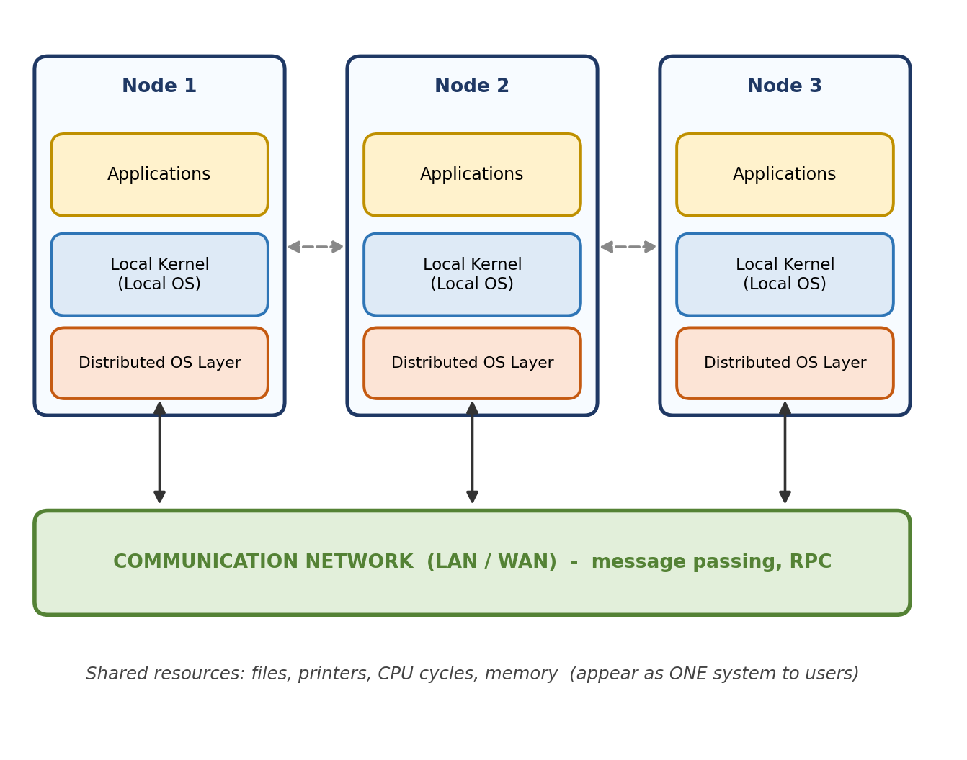
Fig. 5: Distributed OS architecture with communication between nodes
Each node has its own local kernel, with a distributed OS layer above it. The nodes communicate only through the network by message passing and remote procedure calls (RPC), and the distributed layer provides transparent access to remote files, devices and processes.

(c) System call sequence for inter-process communication (IPC)
Message passing between nodes (socket IPC):
Step | Server process | Client process
1 | socket() create endpoint | socket() create endpoint
2 | bind() attach address and port | None
3 | listen() wait for connections | None
4 | accept() accept the connection | connect() request the connection
5 | recv() receive request | send() send request
6 | send() send reply | recv() receive reply
7 | close() | close()

Local IPC (processes on the same node): pipe() → fork() → write() / read() → close(), or shared memory: shmget() → shmat() → read/write → shmdt() → shmctl().
Example: local IPC using a pipe
#include <stdio.h>
#include <unistd.h>
#include <string.h>
#include <sys/wait.h>
int main() {
int fd[2];
char buf[50];
pipe(fd); // 1. create pipe
if (fork() == 0) { // 2. child process
close(fd[0]);
write(fd[1], "Hello from child", 17); // 3. send message
close(fd[1]);
} else { // parent process
close(fd[1]);
read(fd[0], buf, sizeof(buf)); // 4. receive message
printf("Parent received: %s\n", buf);
close(fd[0]);
wait(NULL);
}
return 0;
}

Output:
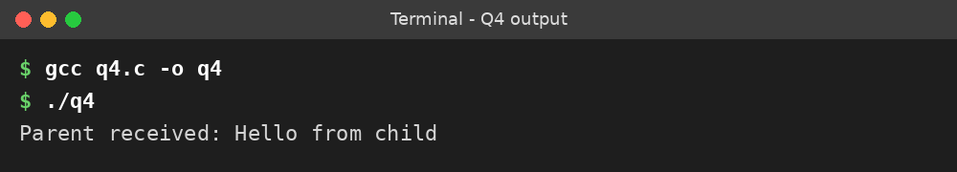
Summary: A distributed OS makes many networked computers behave as one system. Unlike a centralized OS it uses message passing, scales easily and tolerates node failure. Sockets (and pipes or shared memory locally) provide IPC.

Question 5:
Operating system functions: the OS acts as resource manager and control program. It allocates the CPU, memory and devices to processes efficiently and fairly, and prevents conflicts.

(a) Major functions of an OS
Task | How the OS handles it
Process scheduling | The scheduler selects which ready process gets the CPU using algorithms such as FCFS, SJF, Round Robin and Priority. The dispatcher performs the context switch. Goals: high CPU utilisation, throughput and low waiting time.
Memory allocation | Keeps track of free and used memory, allocates memory to processes (contiguous allocation, paging, segmentation), provides virtual memory, protects address spaces and reclaims memory when a process ends.
Device communication | Uses device drivers and device controllers. Handles I/O requests through interrupts, buffering, caching and spooling, and schedules disk requests, giving a uniform interface to devices.

(b) Block diagram of OS components and interactions
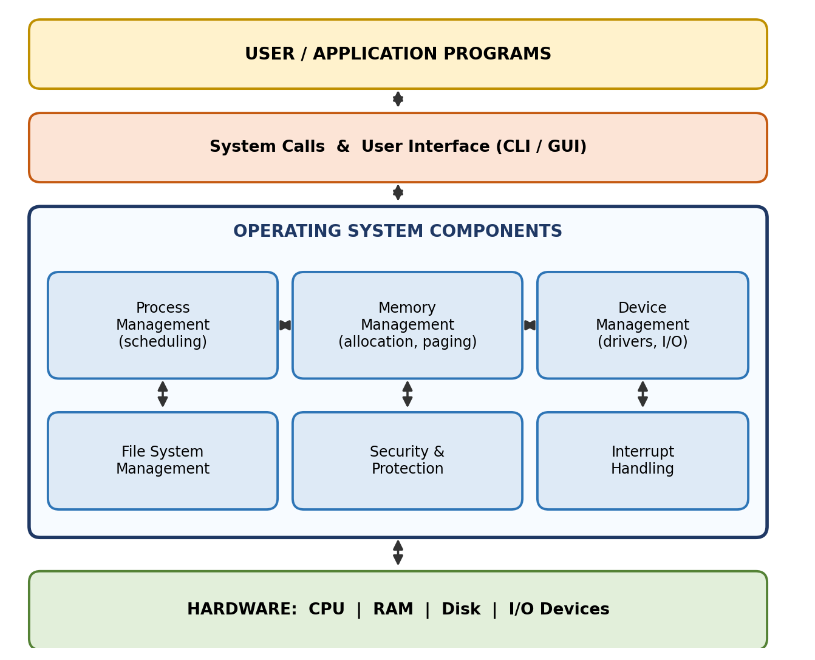
Fig. 6: Block diagram of OS components
Programs enter through system calls. Process management works with memory management (to load processes), and with device and file management (for I/O). Security and interrupt handling support all components, and the hardware sits at the bottom.

(c) System call examples for memory allocation and device management
System call | Purpose
brk() / sbrk() | Extends the heap; used internally by malloc().
mmap() / munmap() | Maps/unmaps memory regions (large allocation, memory-mapped files).
malloc() / free() | C library functions built on the above calls to allocate and release memory.
open("/dev/...") | Requests a device.
read() / write() | Input and output on the device.
ioctl() | Gets or sets device parameters (for example baud rate).
close() | Releases the device.

#include <stdio.h>
#include <stdlib.h>
#include <fcntl.h>
#include <unistd.h>
int main() {
/* Memory allocation */
int *p = malloc(10 * sizeof(int)); // allocate
int sum = 0;
for (int i = 0; i < 10; i++) { p[i] = i; sum += p[i]; }
printf("Allocated 10 ints, sum = %d\n", sum);
free(p); // release

/* Device management */
unsigned char buf[4];
int fd = open("/dev/zero", O_RDONLY); // request device
read(fd, buf, 4); // receive data
printf("Read from /dev/zero: %d %d %d %d\n",
buf[0], buf[1], buf[2], buf[3]);
close(fd); // release device
fd = open("/dev/null", O_WRONLY);
int n = write(fd, "Hello", 5); // send data
printf("Wrote %d bytes to /dev/null\n", n);
close(fd);
return 0;
}

Output:
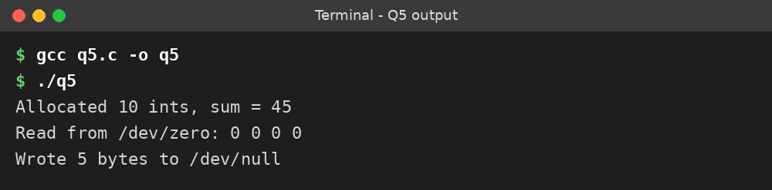
Summary: The OS schedules processes, allocates and protects memory, and controls devices through drivers and interrupts. Calls such as brk/mmap and open/read/write/ioctl give programs access to these services.

